LIFE SYSTEMS: THE MUSCULAR-SKELETAL SYSTEM

PATIENT HISTORY PACKAGE #1

Name: _____________________________________
Date: ______________________________________
Period: _____________________________________

Patient History Form

Name: ————— —————————
Recent Hospitalizations:

- 10/10/2013: Joint inflammation, water drained from behind knee.
- 12/21/2013: Shortness of breath/chest pain
- 1/27/2014: Inability to raise right hand, numb feeling in right arm from the should down.
Age: 65
Sex: Female

Current Medication List (amounts and side effects)

- Rheumatrex (250 mg): Can cause abdominal pain, hair loss, light senstitivity
- Imuran (10 mg): Fever or chills, loss of appetite, liver problems, extreme fatigue and rarely lymphoma cancer

Patient History

Female patient presented with joint pain at the age of 55, stating that most of the pain is found in her knee joints. No previous injury done to either knee joint although patient used to run 20 miles per week on average. Was treating knee pain with Ibuprofen 3 times a day and ice/heating pads as needed. Briefly saw a physical therapist in 2010 to help build strength in the tendons and ligaments surrounding the knee. Physical therapy briefly helped reduce pain and swelling in the knee joints.

Starting in 2011, patient was consistently experiencing “morning stiffness”, the inability to move joints fluidly. Patient said morning stiffness only lasted originally only lasted approximately 20 minutes but now lasts upwards of 60 minutes on a daily basis.

Recently this female patient has noticed the same pain and joint swelling in both of her hands and wrists, making daily tasks (cleaning, writing, typing, etc) difficult for her to complete.
DIAGNOSIS:

Diagnosis is dependent on test results from a CRP (C-reactive protein) and anti-CCP test. High levels of anti-CCP indicate the presence of Rheumatoid Factor
Class Notes

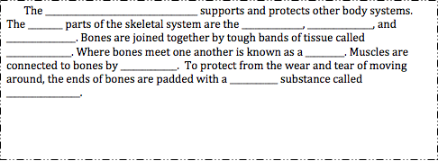
KEY POINTS!

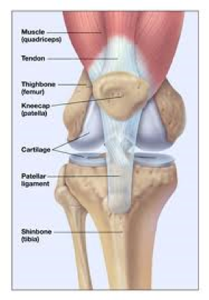

Watch the BrainPop! Video and define the following words using FULL sentences

1. Joint:

2. Cartilage:

3. Ligament:

4. Tendon
The picture above shows the different important parts of a joint. Ligaments connect bone to other bone. Tendons help connect your bones to muscles (so you can move!) Joints are what allow your skeletal system to move. Without them you’d be stiff as a board. Cartilage is important because it serves as a special buffer between your bones so they don’t grind on each other.
Quick!! STOP-N-JOT! List as many joints in the body that you can think of!
Group Reading: Why Your Bone Health Matters!

We are going to read this aloud together. As we read we should underline important details so that we can answer the question “What bone diseases exist and how do they form?”
READING QUESTIONS (answer on clean sheet)

What is rickets and what causes it?

List 2 ways you can prevent rickets.

Explain why rickets is less common today than it was during the industrial revolution
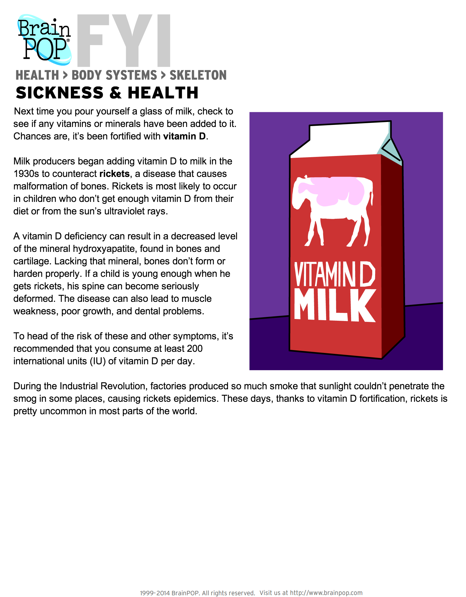

Our Patient:

With a partner, refer back to our patient history page and fill out the following information. There is also a section for you to write down questions you may have about this patient.

Patient Age? ___________________
Patient Sex? ___________________

How many medications is this patient currently taking? __________________

Summarize the patients symptoms in 2-3 FULL sentences:

____________________________________________________________________________________________________________________________________________________________________________________________________________________________________________________________________________________________________________________________________________________________________________________________________________________________________________________________________________________________________________________________________

Has this patient been hospitalized before? If so, when?

__________________________________________________________________________________________________________________________________________________________________________________________________________________________________________________________________
Questions I still have are… (e.g., “what does this medication do?”, “why did they run this test?”, “is there a family history of disease?”, etc)

Computer Research Activity: (10 minutes)

Using the symptoms and medication list provided, research a possible diagnosis for our patient. That is, based upon what we know from her history, what disease or ailment might our patient be suffering from?
Homework:

Read the attached pages on the purpose of the skeletal system. This is a review of what we did in class. After you have finished reading the pages you should answer the questions that follow as part of a reading quiz.

This homework will be due tomorrow at the start of class!
SKELETONS INSIDE AND OUT
Skeletal systems come in many forms. You have a skeleton inside of your body (endoskeleton) made up of bones. Insects and crustaceans have skeletal systems on the outside or their bodies (exoskeletons) that are made of hard plates.

Skeletons hold up the structure Organisms like starfish do not have bones or plates. They have skeletons made up of fluids inside of tubes within their bodies. The fluid skeletal systems are called hydrostatic. All animals that live outside of the water need some kind of skeletal system to support or protect them.

WHAT DOES THIS SYSTEM DO?
We already hinted at the purpose of a skeletal system. Protection and support are the two big reasons that organisms have skeletal systems. In your body, the skeleton works very closely with the muscular system to help you move. Without the bones of your skeleton, you would be a blob of water-filled tissues. The bones create a framework to which your muscles and organs can connect. Your skeleton also plays a role in protection, especially in your head. The bones of your skull protect your all-important brain. Your ribs protect most of your internal organs from impact as well. Other animals with exoskeletons receive obvious protection from their skeleton. Crabs and insects have hard shells made of chitin to protect their entire bodies.

INTERACTING WITH OTHER SYSTEMS
Your skeletal system does not work alone. We already mentioned the interaction with your muscular system. Muscles connect to your skeleton and they contract and move the skeleton along. Your skeletal system is made up of cartilage and calcified bone that work together. They help the process of movement happen in a smoother manner. The calcified bones of your skeleton also work with the circulatory system. Marrow inside of your bones helps produce the cells inside of you blood. Both red blood cells and white blood cells are created in your bones.

GENETIC VARIATION
Location of yellow marrow Sometimes your skeletal system and the tissues of your skeleton can have problems. Some genetic diseases cause individuals to grow excessive large and thick bones. Acromegaly is the term used to describe a condition that affects the pituitary gland and causes an excessive amount of growth hormone to be produced.

Other diseases cause problems with bone formation and related connective tissues including collagen. These genetic diseases can cause bones to become brittle and break easily, while the collagen of the body does not have the strength of a healthy individual. If everything is working correctly, bones are able to break and then heal. Even older people who break their bones can grow new bone and connective tissue that returns the bone to a usable state.

