Dear
Dr. Smith,

Attached is a high priority report sent to us from the hemotology, oncology, and pediatrics lab here in the hospital. Unfortunately, it appears there has been a mix-up of biopsy samples and some of our highest profile patients are at a risk of a misdiagnosis and death.

We need to get a group of research technicians on this ASAP and have them rematch the proper before and after biopsy samples for each of the tissue types.

Please let me know if you can send your top research and lab technicians to me. The attachment is below

Dr. John Smith, M.D./PhD
Yale New Haven Oncology Department
20 York St
New Haven, CT 06510

Dr Smith:

There was a mix-up with pre- and post-treatment biopsy samples for a number of our patients with different diseases. This mix-up is highly unfortunate as some of our patients are suffering from different types of cancer, infectious diseases, and a fatal blood cell mutation.

We are asking for a special task support team comprised of the hospitals very best research and lab technicians who specialize in tissue sampling and biopsy techniques. Please let me know as soon as possible so we can rectify this problem.

Best,

Marna P. Borgstrom
CEO Yale New Haven Hospital

RESEARCH TECHNICIAN LABORATORY MANUAL
BIOPSY SAMPLE AND TISSUE IDENTIFICATION

LAST UPDATED MAY 2014

YALE NEW HAVEN HEALTH CARE SYSTEM

SERVING THE PEOPLE OF CONNECTICUT SINCE 1826

Biopsy Samples from Yale New-Haven Hospital

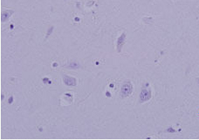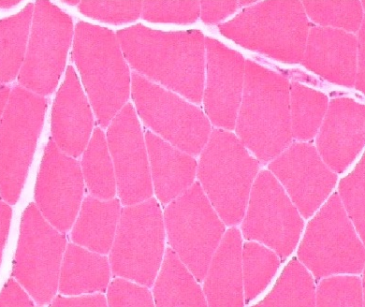

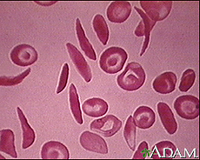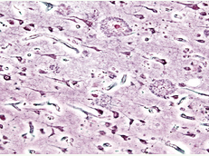

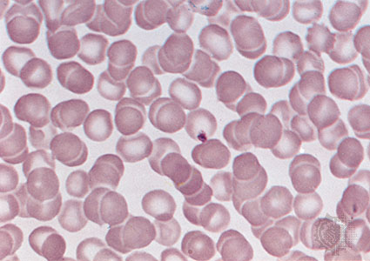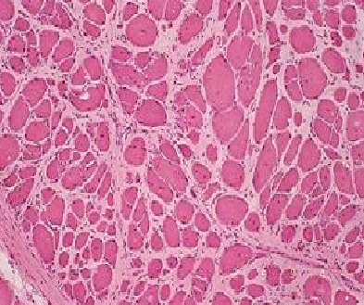

Patient History Form
Name: ————— —————————
Age: 14
Sex: Female

Patient History:
Patient is a 14-year-old Black female, diagnosed with Sickle Cell Anemia at the age of 5 months. Sickle cell anemia affects the red blood cells in the body, causing some to form a characteristic sickle shape. Symptoms have presented themselves in often severe circumstances requiring multiple hospitalizations. Patient also is anemic and takes iron supplements to help manage the fatigue commonly associated with the anemia. Genetic testing reveals both the patient’s mother and father carry the gene for sickle cell. Patient has been hospitalized on multiple occasions for leg ulcers that do not heal, as well as a case of jaundice at the age of 12.

Her most recent “sickle cell crisis” occurred immediately prior to this most recent hospitalization, necessitating the administration of fluids, NSAIDs to manage pain, and the blood samples to test to see whether the patient qualifies for a bone marrow transplant.

Current Medication List:
Peniciilin (Antibiotic): 250 mg x 2/day (only for infections)
Hydroxyurea: 525 mg (used to treat sickle cell crisis)
Ibuprofen: 250 mg up to 6 times a day
Iron Supplement: 25 mg/day

Immunization Status: Vaccinations up to date

Diagnosis
Patient suffers from sickle cell anemia, with the highest risk of sickle cell crisis possible. Patient shows the genetic markers for the disease, which is made worse by severe anemia.

Prognosis
Patient has been placed on a bone marrow transplant list in order to receive a potentially curable treatment. Recent studies have shown that in certain cases a bone marrow transplant can cure individuals of sickle cell anemia. Gene therapy serves as a second option. With management of pain, but without a transplant, patient is terminal with a maximum life span of 22-24 years.

Patient History Form
Name: ————— —————————
Age: 17
Sex: Male

Patient History:
Patient is a 17-year-old Caucasian male patient diagnosed at the age of 4 with the sex-linked disease Duchenne Muscular Dystrophy. Patient began receiving physical therapy for the disease immediately following the diagnosis of DMD. Patient is confined to a wheelchair and body scans show a rapid deterioration and loss of muscle mass in the pelvic region, legs, arms, and neck. Genetic testing of parents reveals that the mother is a carrier for the disease. Patient also suffers from scoliosis (curvature of the spine) due to lack of muscle mass along the spine.

The disease causes the lack of dystrophin, which is needed to help connect muscle cells to the tissue beneath them. Lack of dystrophin allows water to enter the mitochondria in cells, bursting the mitochondria and killing the powerhouse of the cell.

Current Medication List:
None

Diagnosis
Genetic testing confirms a mutation on the short arm of the X-chromosome in the patient in the location associated with Duchenne Muscular Dystrophy. Muscle biopsies confirm the diagnosis. Over the last decade since diagnosis the patient has lost mobility, undergoing a brief period using walking braces, and finally was provided a wheelchair at the age of 15 to help with mobility.

Prognosis
DMD is a progressive, degenerative disease that results in death, typically by the age of 25. Current research is working to identify potential drug and gene therapy treatments but no current research has progressed past the second stage of clinical trials. Patient is currently receiving physical therapy treatment to help with mobility and to maintain as much muscle mass tissue as possible. The patient’s family has completed home modifications in order to allow the patient to use a wheelchair in his home.

As research trials are completed we will continually re-evaluate this patient’s ability to safely participate in those trials.

Patient History Form
Name: ————— —————————
Age: 72
Sex: Male

Patient History:
Patient is a 72-year-old Caucasian male suffering from the neurological disorder of Alzhemiers. Patient was diagnosed at the age of 70 with the disease and was receiving therapy to help with the physical, emotional, and mental complications of the disease. Patient is in the care of his eldest son and has been receiving home care through a private nursing company.

Patient had a double bypass surgery at the age of 62 and routine blood testing confirms that patient’s blood pressure is high, as well as cholesterol levels. Patient takes daily medication to help reduce the side affects of these chronic health problems.

Patient entered a nutrition program after his bypass surgery to help manage weight and stress.

Current Medications
For management of Alzheimer’s Symptoms:
Namenda: NMDA inhibitor
Razadyne: No longer taking this medication
Exelon: No longer taking this medication

For treatment of high blood pressure and high cholesterol
Atenol: 100 mg/day
Atorvastatin: 20 mg
Losartan 25 mg

Diagnosis
Patient has progressed from the mild to moderate stages of Alzheimer’s to moderate to severe Alzheimer’s. Patient has recently been prescribed Namenda to help moderate these later stages. Namenda prevents the breakdown of a chemical in the brain related to memory and thinking. Namenda has a limited life and studies show it eventually stops working.
Prognosis
Patient will eventually be moved into private hospital care as memory and thinking capabilities are rapidly deteriorating. Patient continues to receive therapy related to managing the stress and anxiety of living with Alzheimer’s. Brain scans continue to show descreased neurological functioning in the hippocampus and overall decreased function. Brain tissue sample shows nervous tissue that shows “strangled” nerves.

Partner Work:

With your partner research technician, analyze the tissue sample pictures and read the patient profiles. Once you have completed both of those things, answer the questions below. As research technicians for Yale New Haven Hospital you are responsible for correctly identifying the normal and abnormal tissue samples.

Hint: Each patient profile is associated with two different tissue samples on page three. Use those patient history pages to help identify the correct samples that go with each disease.

PREDICT: Based upon the patient profiles, fill in the boxes below for the normal and abnormal tissue samples as a prediction

 | Normal Tissue Sample Number (1-6) | Abnormal Tissue Sample Number (1-6)
Anemia
(affects blood cells)
Alzheimer’s
(affects brain cells)
Duchenne Muscular Dystrophy
(affects muscle cells)

Questions:

- Sickle Cell Anemia forms red blood cells that are shaped like sickles, or a flattened disc like a dagger. Based upon this, what tissue sample is representative of the patient with sickle cell? ____________________________

- Identify the tissue sample that is representative of a normal blood cell sample ____________

- Describe what healthy, normal blood cells look like
_______________________________________________________________________________________________________________________________________________________________________________________________________________________________________

- Compare the normal and abnormal blood tissue samples for the patient with sickle cell anemia. What complications do you think arise in our patient with sickle cell? How might sickle cell affect the way blood cells move through the body?
_______________________________________________________________________________________________________________________________________________________________________________________________________________________________________

- Muscle cells are mitochondria packed cells that are typically packed close together in non-circular shapes. Which tissue sample represents normal muscle tissue? _________________
- Re-read through the patient history sheet for the young male suffering from Duchenne Muscular dystrophy. Based upon this profile of the disease and your answer to question 5 above, what tissue sample represents the tissue sample of our patient with Duchenne Muscular Dystrophy? Explain your answer choice using evidence from the tissue sample picture and the patient profile
_______________________________________________________________________________________________________________________________________________________________________________________________________________________________________
_______________________________________________________________________________________________________________________________________________________________________________________________________________________________________

- Alzheimer’s is a disease that affects which type of cell?
  - Muscle
  - Nerve
  - Bone
  - Blood

- Alzheimer’s causes the rapid degeneration of brain cells in a patient. Neurons tend to look “stringy” and thin as they die off. What two tissue samples belong to the patient with Alzheimer’s disease before the disease affected his brain and after the disease began to affect this brain.

  - Before disease: _______________________

  - After disease: _________________________

- Which of the patient’s suffers from a sex-linked disease? How do you know?
__________________________________________________________________________________________________________________________________________________________

- Based upon the tissue cell samples for the patient with Alzheimer’s disease, do you think the mass of the brain of a person suffering from Alzheimer’s increases or decreases? Why?
__________________________________________________________________________________________________________________________________________________________

- What are some ways that the shape of a cell can affect its function? Use specific examples from today’s lesson to help support your answer.
__________________________________________________________________________________________________________________________________________________________
__________________________________________________________________________________________________________________________________________________________

