Patient Name:___________________________________ Patient DOB: ________________ Age:______

Patient Sex: ________________ Phone Contact:__________________ Insurance:__________________

Preliminary Information

August 23rd, 2007: Male and female remains were located at a bonfire site outside of Yekaterinburg. Bodies were heavily decomposed and showed signs of burn damage. Archaeologists believe the partial male remains belong to a boy between 10 and 13 years of age and the female remains belong to a woman between the ages of 18 and 23 years of age. Located amongst the remains were nails, sulfuric acid, and bullets. A small strip of striped fabric was found amongst the remains. Initial guesses place the time of death of both individuals around July 1918. DNA testing will be used to cross-list the remains to determine relationship between the male and female remains and possibly identify the remains.

DNA Testing Results
- DNA testing confirms that male and female remains are related, most likely siblings, with over 99% certainty.
- Genetic testing reveals an anomaly on the X chromosome of the male remains.
- Female DNA testing shows same anomaly on one X-chromosome but the second copy of her X chromosome is free of the genetic mutation.
- Genome mapping confirms that this region on the X-chromosome is typically associated with hemophilia B.
- Karyotyping of the X-chromosome is shown below
Male Remains | Female Remains
Genetic Makeup: XY | Genetic Makeup: XX
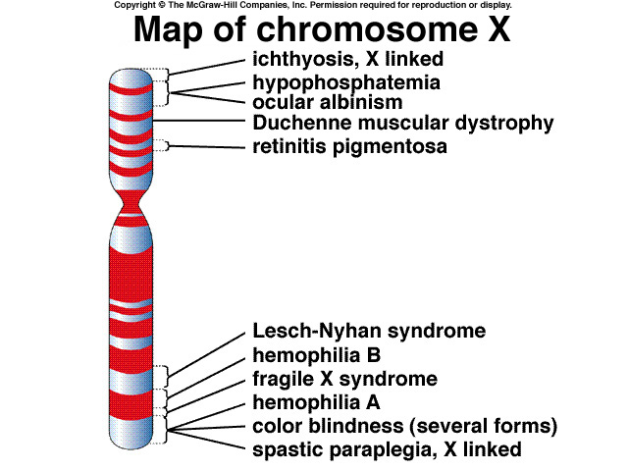 | 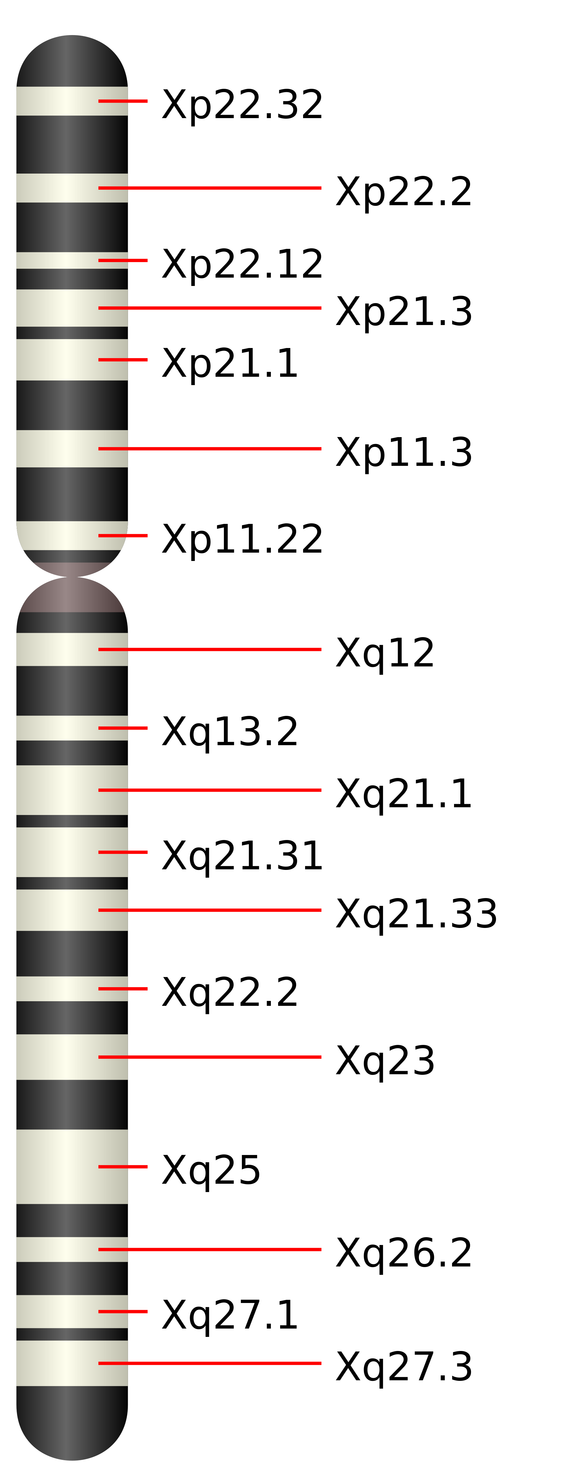

IDENTIFICATION OF HUMAN REMAINS
Cross-listing of DNA test reveals a very high likelihood that male remains are the remains of Alexei Nikolaevich, tsarevich of Russia and only male son to the former Russian Tsar Nicholas II. Female remains belong to one of his sisters. The Russian family was murdered on July 17th, 1918. Subsequent tests will be completed to confirm this DNA testing result

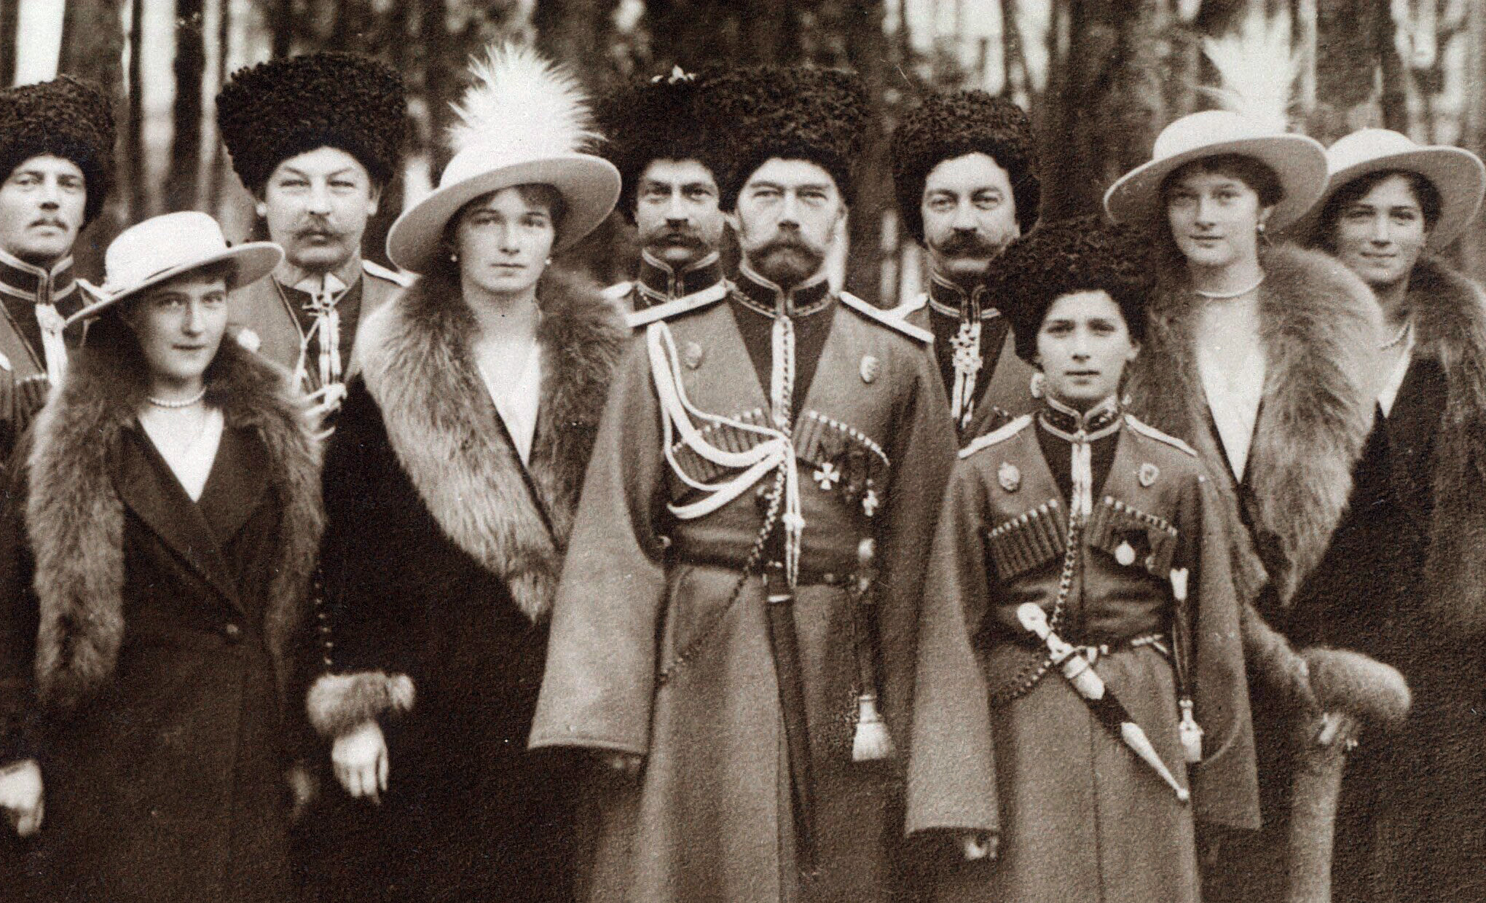
The Romanovs visiting a regiment during World War I. From left to right, Grand Duchess Anastasia, Grand Duchess Olga, Tsar Nicholas II, Tsarevich Alexei, Grand Duchess Tatiana, and Grand Duchess Maria, and Kuban Cossacks

Hemophilia is a blood disorder in which a clotting factor is not produced, leading to uncontrolled bleeding. Hemophilia played a prominent role in royal European families during the 19th century. Queen Victoria, who sat on Britain’s throne from June 1837 till her death in 1901. In addition to providing heirs to the throne she also passed on a genetic mutation, called hemophilia, to two of her five daughters. This mutation would spread across royal blood lines across the European continent, affecting royal families of Spain, Germany, and Russia. Below is a pedigree showing the Russian bloodline that is directly descended from Queen Victoria.

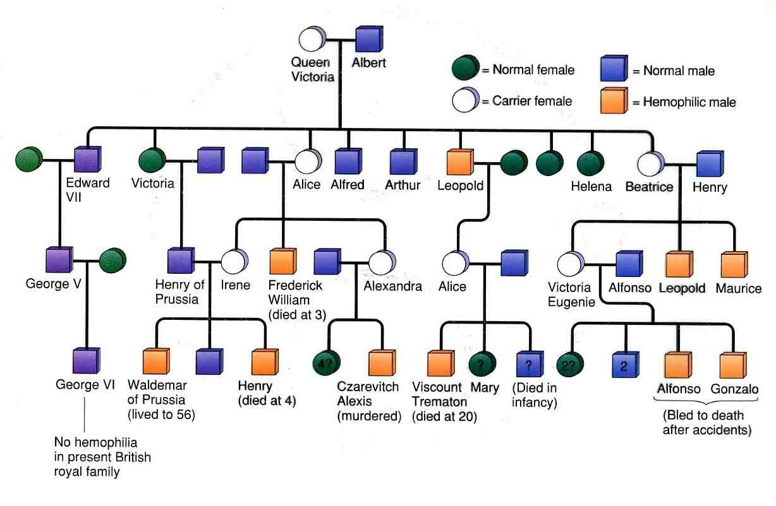
Pedigree Overview: Answers the questions below with a partner using a quiet indoor voice.

- According to the pedigree legend, what symbol represents a normal female?

- According to the pedigree legend, what symbol represents an affected male?

- Locate Irene and Henry of Prussia on the pedigree.
  - Did Henry of Prussia suffer from hemophilia? _____________________
  - Was Irene a carrier of the genetic mutation for hemophilia? ______________________
  - How many of their three children suffered from hemophilia? ________________
- How many affected females (not carriers) are there in the pedigree? _____________________
- How many carrier males (not those affected) are there in the pedigree? ___________________
- How many affected males are there in the pedigree? _________________________
- How does having a carrier mother affect the number of affected males that are born? That is, does having a carrier mother increase or decrease the likelihood of having sons who suffer from hemophilia. Use concrete evidence, such as names, from the pedigree to support your answer.
___________________________________________________________________________________________________________________________________________________________________________________________________________________________________________________________________________________________________________________________________________________________________________________________________________
- All humans have a pair of “sex chromosomes”, which determine the sex of an individual. Males are XY and females are XX. If hemophilia is found on the X chromosome, why do you think more males are affected by hemophilia than females?
___________________________________________________________________________________________________________________________________________________________________________________________________________________________________________________________________________________________________________________________________________________________________________________________________________

